COMPOSED PLATTERS

CRUDITÉ
Assorted vegetables and herb-ranch, bleu cheese dressing, or roasted red pepper hummus $5.95 pp

SLICED CHEESE PLATTER
Smoked gouda, Swiss, yellow cheddar, pepper jack, and provolone cheese slices, served with crackers and garnished with fruit $8.95 pp

CHEESE WEDGE TRAY
Assorted aged soft and firm cheese wedges accented with dried fruit, nuts, and served with assorted crackers and bread $8.25 pp

ANTIPASTO
Salami, capicola, marinated mushrooms, roasted red peppers, kalamata olives, cherry peppers, asiago, provolone, and fresh mozzarella with focaccia and ciabatta bread $10.95 pp

MEXICAN FIESTA
Six-layer Mexican dip with guacamole, salsa, tomatoes, black olives, sour cream, and shredded cheddar, with tri- color corn tortilla chips $7.95 pp

MEDITERRANEAN
(25-person minimum)
Tabbouleh, red pepper hummus, baba ghanoush, stuffed grape leaves, marinated olives, and pita chips $8.95 pp

SMOKED SALMON PRESENTATION
Smoked Atlantic salmon side with lemon cream cheese, capers, red onion, and pumpernickel triangles $13.95 pp

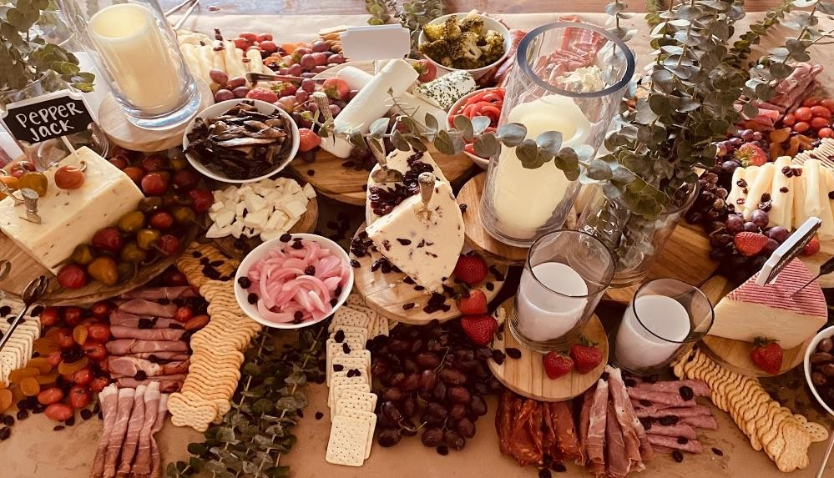

All pricing is subject to 7% state tax and 3% administrative fee

THERE’S ALWAYS ROOM FOR ICE CREAM

ICE CREAM SOCIALS

We feature assorted Richardson’s own ice cream and frozen yogurt flavors hot and cold sauces, and over a dozen toppings

What’s your favorite combination?

We can coordinate this as a drop-off or have staff in attendance to make your guests’ selection

your selection of three flavors

Richardson’s ice cream and frozen yogurt flavors

your selection of two

hot fudge, caramel, fluffernutter, butterscotch, crushed pineapple, and strawberry topping

your selection of seven

whipped cream, rainbow or chocolate sprinkles, M&Ms, Reese’s Pieces, Heath Bar topping, maraschino cherries, gummy bears, Oreo cookie pieces, and chopped walnuts are our featured toppings, but if
you’re craving something that you don’t see here, please ask!

Service is highly recommended for replenishing supplies and cleanup.

$9.95 PER PERSON

All pricing is subject to 7% state tax and 3% administrative fee

Only two pages were converted.
Please Sign Up to convert the full document.

www.freepdfconvert.com/membership

