HOT LUNCH BUFFET

$18.25 per person
all entrées include garden salad, desserts and paper products unless otherwise specified second selection is an additional $4.50 pp

BEEF
marinated grilled BBQ steak tips ($1.50 up-charge per person) marinated grilled sirloin steak with corn and black bean salsa spicy, crispy Chinese beef with Asian vegetables
beef fajitas with flour tortillas and Mexican condiments and toppings

CHICKEN AND TURKEY
stuffed chicken breast: artichoke-leek, spinach-boursin, or wild rice-mushroom with creamy gravy chicken fajitas with flour tortillas and Mexican condiments and toppings
marinated grilled chicken breast with Mediterranean salsa
traditional chicken piccata: egg-battered chicken breast with piccata sauce chicken marsala with sautéed mushrooms
Chinese chicken stir-fry with Asian vegetables
oven-roasted turkey breast with herb stuffing and gravy

PORK
sage-mustard glazed pork loin with maple-dijon cream sauce herb-roasted pork loin with thyme gravy

VEGETARIAN
spinach-boursin stuffed portobello mushrooms
summer squash vegetable stack with fresh mozzarella and tomato coulis gnocchi with wild mushrooms and vegetables in parmesan cream sauce Asian vegetable stir-fry

SEAFOOD
$2.99 pp additional charge
shrimp scampi with pasta, sun-dried tomatoes, and scallions marinated grilled swordfish kabobs with grape tomatoes ancho-glazed Atlantic salmon with pineapple salsa

ITALIAN ENTRÉES
all Italian entrées come with an antipasto salad
jumbo stuffed shells or baked manicotti and meatballs in marinara
meat lasagna with marinara or vegetable lasagna with alfredo and meatballs eggplant or chicken parmesan with penne pasta and marinara

SPECIALTY SALADS
Caesar or up-country salad ($1.25 pp up-charge)

All pricing is subject to 7% state tax and 3% administrative fee

SIDES
not included with Italian entrées or fajitas

oven-roasted potatoes wild rice
herbed rice pilaf Spanish rice
sesame lo mein noodles baked macaroni and cheese maple-glazed carrots
green beans amandine corn and black bean salsa seasonal vegetable medley
basil risotto ($.50 pp up-charge) buttered asparagus ($.95 pp up-charge)

Buffet Includes:
served with dinner rolls and butter
cookies and dessert bars, and all necessary disposable dinnerware.

SOUPS
minimum order of 10

traditional New England clam chowder $5.25 per person
butternut squash-apple bisque $4.25 per person
chicken noodle $4.50 per person
classic Italian minestrone $5.00 per person
roasted tomato bisque $3.50 per person
seasonal soup

all menu items and pricing subject to change

All pricing is subject to 7% state tax and 3% administrative fee

COMPOSED PLATTERS

CRUDITÉ
Assorted vegetables and herb-ranch, bleu cheese dressing, or roasted red pepper hummus $5.95 pp

SLICED CHEESE PLATTER
Smoked gouda, Swiss, yellow cheddar, pepper jack, and provolone cheese slices, served with crackers and garnished with fruit $8.95 pp

CHEESE WEDGE TRAY
Assorted aged soft and firm cheese wedges accented with dried fruit, nuts, and served with assorted crackers and bread $8.25 pp

ANTIPASTO
Salami, capicola, marinated mushrooms, roasted red peppers, kalamata olives, cherry peppers, asiago, provolone, and fresh mozzarella with focaccia and ciabatta bread $10.95 pp

MEXICAN FIESTA
Six-layer Mexican dip with guacamole, salsa, tomatoes, black olives, sour cream, and shredded cheddar, with tri- color corn tortilla chips $7.95 pp

MEDITERRANEAN
(25-person minimum)
Tabbouleh, red pepper hummus, baba ghanoush, stuffed grape leaves, marinated olives, and pita chips $8.95 pp

SMOKED SALMON PRESENTATION
Smoked Atlantic salmon side with lemon cream cheese, capers, red onion, and pumpernickel triangles $13.95 pp

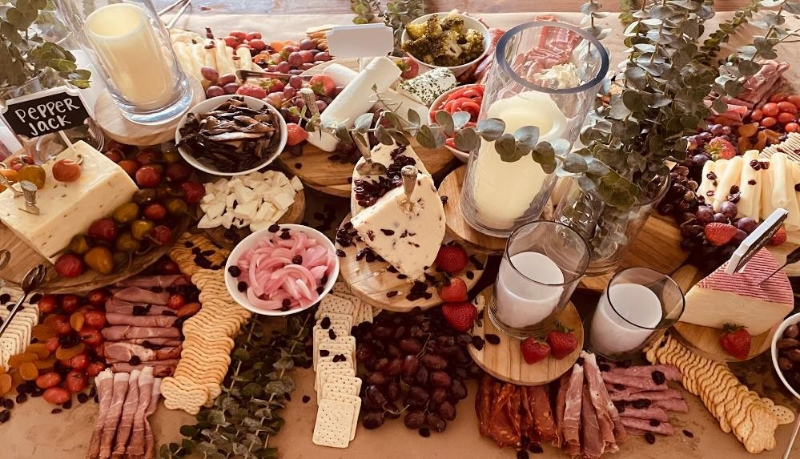

All pricing is subject to 7% state tax and 3% administrative fee

